
SOP Title: | eCommerce Manual Inventory Stock Adjustments
Document Storage Location: | STACS/Management/SOPs – Logistics and Warehousing | Document #: | SEASOP438v100
SOP Originator: | Valentina Popadic | Last Edited by: | Valentina Popadic
Effective Date: | 10/31/2022 | Last Edited Date: | 12/8/2023
Other: | eCommerce Logistics and Warehousing

- Purpose
  - This Standard Operations Procedure establishes process, procedures, and standards for the eCommerce Manual Inventory Stock Adjustments

- Scope
  - Process to occur every time there is request for manual inventory transactions in / out stock

- Responsibilities

  - SEA eComm Operations Team
  - SEA eComm Inventory Team
  - 3PL ( GEODIS)

- Instructions

  - Any manual stock adjustment requires pre approved PUMI document. SEA MX Logistics Team sends request on how many units should be adjusted IN / OUT of stock to 3PL. Units are manually adjusted IN or OUT of stock due to different scenarios:
    - Cycle Count adjustment ( per Weekly PUMI)
    - Miss-Shipment PUMI
    - Any other manual adjustment request ( per specific PUMI approved )

  - Once PUMI approved, SEA MX Logistics Team will forward the list of items to Geodis and request to start processing the adjsutments.

    - 3PL Team will start the process of adjusting in their WMS ( Synapse). In the comment section they will use specific comment that is provided by SEA with their request.
      - A stock items are adjusted in AV stock (unrestricted). This is being done with following steps.
        - Directly from inbound to available: RH-> AV

      - C stock items are being adjusted in C stock (Returns) via 2 ways:
        - Following inbound path and changing statuses accordingly: RH-> AV->RT-> CP
        - Directly into Returns stock (CP)

      - Technical Returns stock items are adjusted in:
        - Directly into Technical Returns stock (SC)

  - SEA eComm Team will perfom adjustments in NERP accordingly ( separate for each of top scenarios).
      - T-Code MIGO
        - Movement type A01 (Goods Receipt) -> A01 GR for Sample option
          - Enter Document Header text accordingly
          - Fill out information needed: Material, Quantity, Cost Center, Plant, Batch and Storage location ( in this order )
          - Check entries
          - Save.
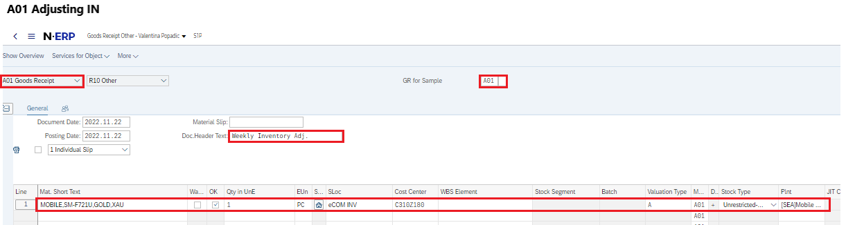

      - T-Code MIGO

          - STEP #1 - Write the product IN
          - Movement type A01 (Goods Receipt) -> A01 GR for Sample option
          - Enter Document Header text accordingly
          - Fill out information needed: Material, Quantity, Cost Center, Plant, Batch and Storage location ( in this order )
          - Check entries
          - Save


- STEP#2 - T-Code MIGO again ( to block the product)
          - Movement type A08 (Transfer Posting) -> 344 TR block to UNR
          - Enter Document Header text accordingly
          - Fill out information needed: Material, Quantity, Plant, Batch and Storage location ( in this order )
          - Check entries
          - Save
IMPORTANT NOTE: Following morning check the stock comparison gap for WC1E and WR2E storage locations and make proper corrections with unblocking WC1E. Reason for unblocking WC1E is due to timing between GEODIS and SEA transactions. Due to unknown timing for adjustments, GEODIS is performing transactions first and SEA right after that, same day. In case we already have some blocked quantity in WC1E, IDOC to WR2E will occur right after GEODIS performs move from RT -> CP, due to IDOC. This will mean that blocked items that have automatically IDOC’d will need to be unblocked as causing GAP between Unrestricted and Restricted stock.

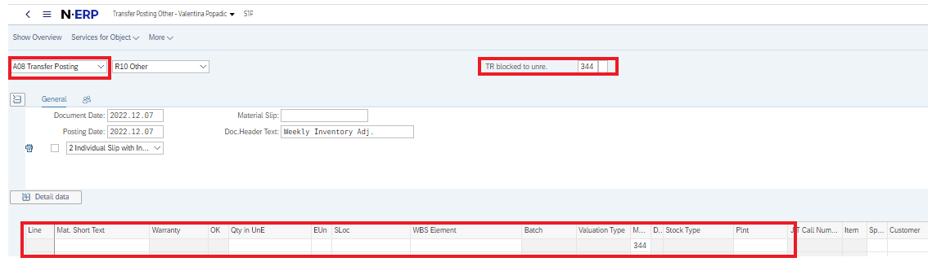

        - Directly into Returns stock (CP)

          - T-Code MIGO Write the product IN
          - Movement type A01 (Goods Receipt) -> A01 GR for Sample option
          - Enter Document Header text accordingly
          - Fill out information needed: Material, Quantity, Cost Center, Plant, Batch ( C ) and Storage location ( WR2E ) ( in this order )
          - Check entries
          - Save

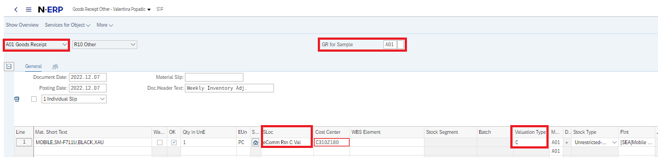

        - Directly into Technical Returns stock (SC)

          - T-Code MIGO Write the product IN
          - Movement type A01 (Goods Receipt) -> A01 GR for Sample option
          - Enter Document Header text accordingly
          - Fill out information needed: Material, Quantity, Cost Center, Plant, Batch ( A ) and Storage location ( WR3E ) ( in this order )
          - Check entries
          - Save
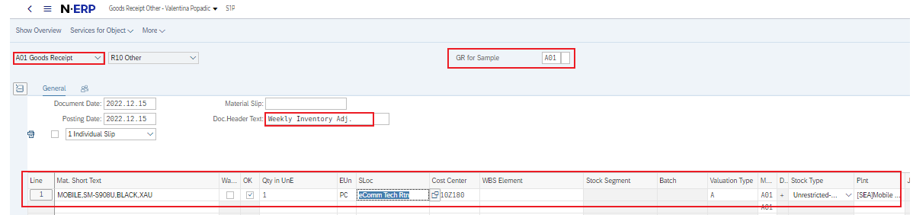

  - Adjsutments OUT of stock are being done same way but backward steps, for below Storage Locations accordingly.
- From WC1E - Each time we use A02 to adjust stock out of WC1E storage location we need to unblock items first ( A08 Transfers – 343 Unblock) and then remove out of stock ( A07 Goods Issue – A02 RE GR for Sample). Both of these transactions are part of MIGO T-code.
Example:
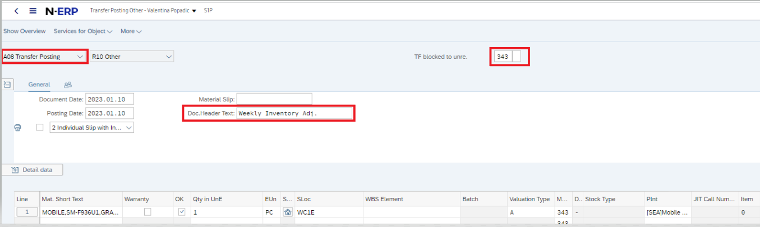

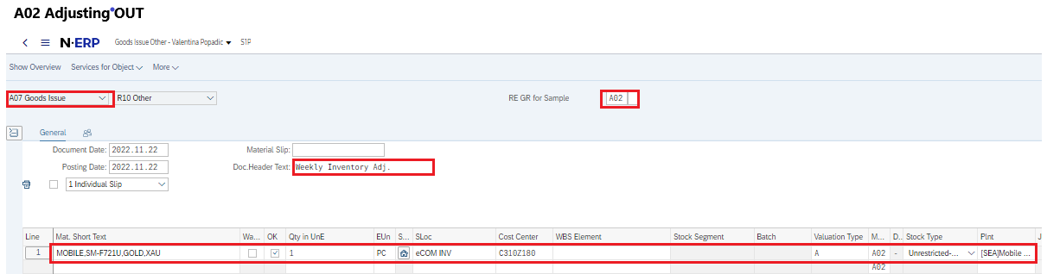

- From WR2E and WR3E – No need for unblock, material is already unblocked in these sloc. Remove out of stock ( A07 Goods Issue – A02 RE GR for Sample).

  - Related Documents

